REsPIRATION
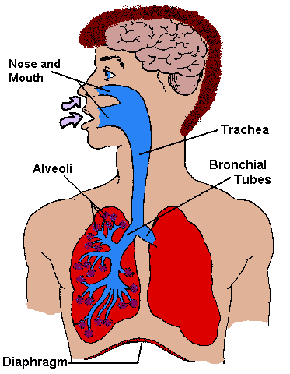

MOUTH AND NOSE
- Your nose connects to the back of your mouth through two tubes.
- The air you breathe in goes from your mouth and nose down to your trachea and into your lungs.
- Your nose is able to block some of the dirt and germs in the air. The dirt and germs in the air get stuck in the mucus in your nose, and they can't enter your lungs. When you blow your nose, you're getting rid of all the bad germs and dirt that your nose stopped from getting into your body.

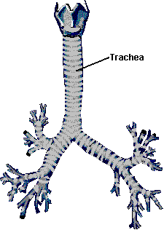

TRACHEA
- Your trachea is the tube that connects your mouth and nose to your lungs.
- Only air goes into your trachea.
- Your epiglottis (flap of skin) covers the trachea when you're eating or drinking. This little flap makes sure none of your food gets into your lungs.

ALVEOLI
When air enters your lungs, it goes through a maze of smaller and smaller tubes until it reaches tiny sacs called alveoli. The sacs look like bunches of grapes at the end of the bronchial tubes. The alveoli are where the oxygen from the air enters your blood, and the carbon dioxide from your body goes into the air. Alveoli are very tiny, but you have a lot of them in your lungs. In fact, you have 300,000,000 alveoli in each lung.
BRONCHIAL TUBES
When the air you breathe in goes down your trachea, it comes to a fork in the road. These are the bronchial tubes. One tube goes into your right lung, and the other goes into your left lung. The bronchial tubes go into your lungs and keep branching off into smaller and smaller tubes until the sacs at the end called alveoli are reached.

They help clean your lungs. They are covered with mucus, which sticks to dirt and germs that get into your lungs. Next, millions of tiny hairs called cilia act like tiny brooms to sweep out the bad stuff caught in the mucus. Each cilium sweeps back and forth about ten times every second! That's 36,000 every hour, 24 hours a day! They do this to keep your lungs clean.

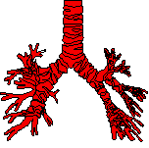
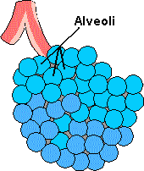

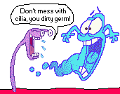

DIAPHRAGM
The diaphragm is a big sheet-like muscle that's at the bottom of your chest cavity. The diaphragm helps you get air in and out of your lungs by moving up and down. When your diaphragm moves down, you breathe in. When your diaphragm moves up, you breathe out!

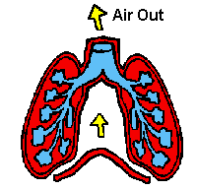
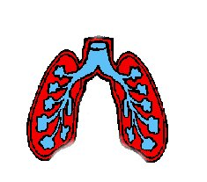
Air In

REFERENCE
http://www.sk.lung.ca/content.cfm

